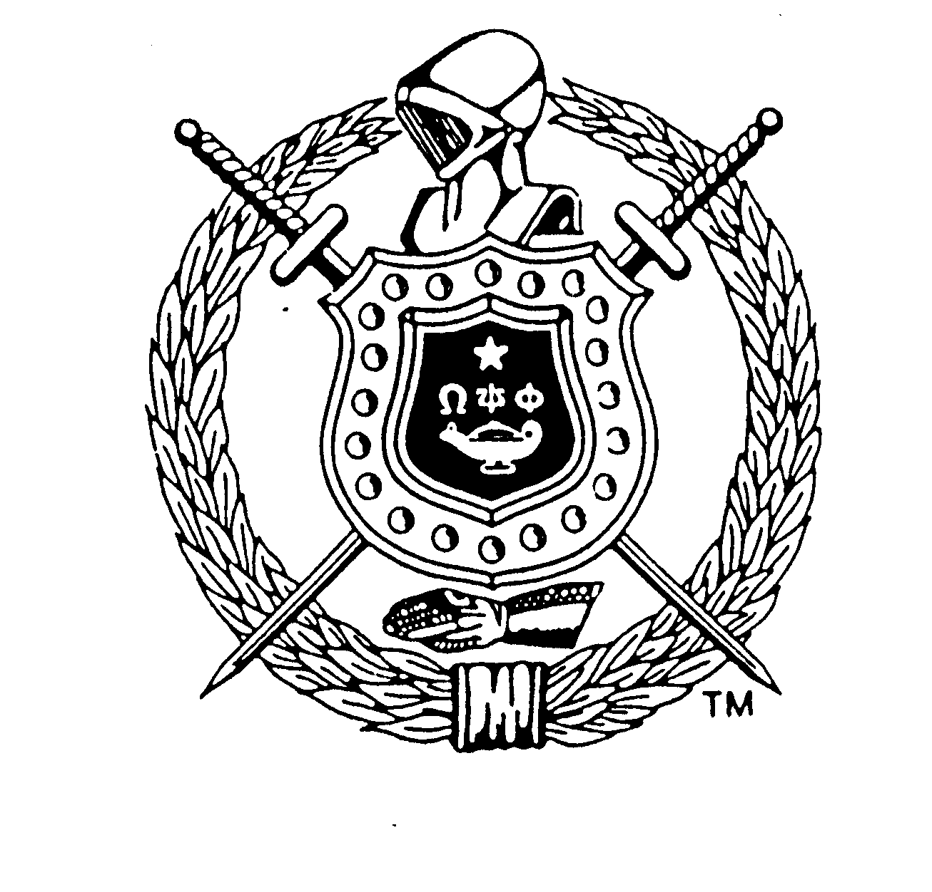
2018 - 2019 International Achievement Week Observance
Theme: “Omega Men: Effecting Positive Change in Communities Worldwide”
Omega Psi Phi Fraternity, Inc.
Announcement of our Annual
International High School Essay Contest
As a mandated element of the Annual International Achievement Week Observance
November 11 - 17, 2018
Awards: Four College Scholarships
1st Scholarship: $5,000; 2nd Scholarship: $3,000; 3rd Scholarship: $2,000; 4th Scholarship: $1,000
Eligibility: The Contest is open to all college-bound, high school seniors who submit an essay application through a Chapter of the Fraternity
Contest Closes: October 19, 2018
RULES
The essay must be entitled:
“How has social media impacted today’s youth, and what influence does it have on their future?”
The essay must be original and neither previously published nor secured by copyright.
The essay must be between 700 and 750 words in length.
The type-written, double-spaced essay may be submitted via postal service or email in Microsoft Word

The following information for the contestant must appear on the first page in this manner:
Title: __________________________________________________________________________________
An Essay By: ___________________________ Home Street Address: ____________________________
City, State, Zip Code: _______________________ Name of High School: _________________________
Address of High School: _________________________________________________________________
Contest Name: Omega Psi Phi Fraternity International High School Essay Contest
Name of Chapter Sponsoring Project: ________________ Location of Chapter: ___________________
The manuscript must be postmarked or time stamped on the email not later than midnight, October 19, 2018, and sent to an Omega Psi Phi Chapter Sponsoring the Essay Contest. Essays are not to be sent to the Fraternity’s Headquarters facility.
Persons submitting manuscripts thereby grant to the Omega Psi Phi Fraternity, Inc. the right to keep the manuscripts and to exercise full publishing rights to them. Awards will be announced on or about June 1, 2019, and the decision of the judges will be final. The manuscripts must present an adequate treatment of the essay topic. Winners may be required to furnish written proof that they were enrolled in their respective high school at the time the essay was submitted. Awards will be submitted to each winner, upon written verification from an institution of higher education that the individual has enrolled. Actual enrollment (not just acceptance) is required. Awards must be claimed within 18 months after the announcement date to be valid.
RATING CRITERIA FOR ESSAYS
- Development of Topic/Thesis: (30 possible pts.) Topic well developed (covers and develops major points, supplying enough information for understanding)
- Progression: (20 possible pts.) Composition progresses from beginning to end in a logical flow of information
- Readability: (25 possible pts.) Concise prose that sticks to the point and does not ramble (holds reader’s attention)
- Grammar: (15 possible pts.) Agreement of subject and verb; proper tense; correct sentence construction; paragraphing, including transitional phrases linking same
- Spelling: (5 possible pts.)
- Punctuation: (5 possible pts.)

